6.2 Managing children who are ill or infectious
Including the following sections:
- Is my child well enough to be at Pre-school
- What happens if my child is taken ill at Pre-school

Policy statement

At Cumnor Preschool Nursery we aim to provide care for healthy children through preventing cross infection of viruses and bacterial infections and by promoting good health.

Is my child well enough to be at Pre-school?
It can sometimes be difficult to know if your child is well enough to be at Pre-school. To help you make an informed and confident decision, we have produced a summary poster ‘Is my child well enough for Pre-school?’ based on NHS and Early Years Alliance (EYA) advice as a guide for parents/carers. This can be found in the Appendix 1 of this Policy. You will also find it on the Pre-school noticeboard and it is provided to new parents in their ‘welcome pack’. Please also see Appendix 2 for the NHS exclusion periods for common illnesses ‘When should my child return to school’. Appendix 1 and 2 should be read in parallel with the full guidance below.

When must I keep my child at home?
If a child has diarrhoea and/or vomiting, they must be kept at home for at least 48 hours following the last episode before returning to Pre-school. They should be feeling well and eating normally.

If a child requires Calpol (or similar medication) to control a high temperature, or other symptoms, they must not come to Pre-school. Calpol can mask other symptoms showing and may cause delay in noticing a more serious infection or illness. A child who needs Calpol is not well enough to attend Pre-school.

A child who has had a raised temperature must not come to Pre-school until the temperature has returned to normal for at least 24 hours. This is because a raised temperature could indicate the start of an infection or illness which may not become apparent until later in the day.

Where a child has been prescribed antibiotics for an infectious illness or complaint, it is advised that parents keep them at home for 48 hours to ensure no adverse effect, and to give it time to take effect.

This is not an exhaustive list of when a child must be kept at home. If parents/carers are at all concerned about the health of their child they must contact their doctor for advice.

If a child appears unwell, lethargic or ‘not themselves’
We would advise parents to keep them at home and monitor them. This could indicate that the child is suffering from a bug or virus and more obvious symptoms may appear later in the day. Viruses and bugs spread quickly amongst the Pre-school age group and we try to reduce transmission as much as we are able.

Pre-school is a busy, noisy place with lots going on, a child who is not feeling well will want to be in a quiet, comfortable place to rest. Whilst we do our best to comfort and care for a poorly child, we cannot give the sustained level of attention they may need, as we have other children at Pre-school to care for. No-one is a substitute for your main caregiver when you are ill. A child who is not feeling well will not enjoy being at Pre-school and will not benefit from their time in the setting; therefore, it is best to keep them at home until they feel better.

Children will often get minor coughs and colds as their immune system develops. Provided the child is well in themselves or are at the recovery stage of a cold they may attend Pre-school. However, staff will monitor the child to check that symptoms do not worsen and may contact parents to collect their child if they feel this is in the best interests of the child.

In all cases, where a child is ill and not attending Pre-school, parents must phone the setting to inform the Manager. This ensures we know what illnesses are present and a decision can be made as to whether to inform other parents of a virus/illness that is circulating – for example chicken pox. No names are used in the notification.

What happens if my child is taken ill during the Pre-school session?
- If children appear unwell during the day – for example, if they have a temperature (above 37.8C), sickness, diarrhoea or pains, particularly in the head or stomach – a call will be made to the parents asking them to collect the child, or to send a known carer to collect the child on their behalf.
- The child's temperature is taken using an infrared digital thermometer which is non-invasive. If the temperature is 37.8C or above the child’s parent is called to collect them as soon as possible. The child’s temperature is checked regularly and recorded whilst awaiting collection.
- If a child has a temperature, we ensure that they are appropriately dressed for their surroundings, with the aim of preventing overheating or shivering. They are encouraged to drink plenty of water to keep them well hydrated.
- In extreme cases of emergency, an ambulance is called and the parent informed.
- Parents may be asked to take their child to the doctor before returning them to the setting; the setting can refuse admittance to children who have a raised temperature, sickness and diarrhoea or a contagious infection or disease.
- If a child has diarrhoea and/or vomiting during their Pre-school session, the parent will be called to collect them as soon as possible. They must be kept at home for at least 48 hours following the last episode before returning to Pre-school.

Contacting parents to collect a child who is unwell
- We understand that many parents are working during the school day, however we do need parents to be contactable at all times when their child is in Pre-school in case their child is taken ill or has an accident and needs to be collected.
- It is the parents’ responsibility to ensure Pre-school has up to date contact details – a phone number where the parent can be contacted during the session. If parents know they will not be available on a particular day they must inform the Pre-school Manager of an alternative person to contact in case of emergency. (Parents provide names of alternative contacts on their initial admission forms but this may differ on a particular day due to specific circumstances such as holidays or work commitments)
- We will only call parents to collect their child from a session if staff believe it is necessary for the wellbeing and health of the child. We do not do this lightly as we are aware that this may not be easy to arrange at short notice. We will always prioritise the best interests of the child.

Procedure for children who have Respiratory Infections
Government Guidance (1 April 2022) advises those with symptoms of a respiratory infection, including Covid19, and a high temperature or who feel unwell, are advised to stay at home and avoid contact with other people, until they feel well enough to resume normal activities and they no longer have a high temperature.

If a child becomes unwell during their Pre-school session with a temperature, new consistent cough/wheeze or other respiratory symptoms the parent will be phoned to come and collect the child. They may return once they no longer have a high temperature, other symptoms have subsided and they are well enough to return to Pre-school.

Confirmed Covid19
Government Guidance (1 April 2022) says that anyone with a confirmed Covid19 positive result will be advised to try to stay home and avoid contact with other people for five days after the day you took your test, which is when they are most infectious.

As with other infectious childhood illnesses, we will adhere to the exclusion period advice given and expect any child with confirmed Covid19 to stay at home for 5 days after the day of the test. Test day is ‘Day 0’. They may return to Pre-school after this exclusion period, provided they do not have a high temperature and feel well enough to attend.

Although Lateral Flow Tests are no longer available for free for most people, they will be available to buy from Pharmacies. We would therefore advise and encourage our families to use a LFT if they have Covid19 symptoms or have been in contact with someone who has confirmed Covid19.

New or Unexplained Rashes
A child with a new or unexplained rash or spots will not be admitted to Pre-school. Some illnesses, for example chicken pox or scarlet fever present with a rash or spots, which are extremely contagious and spread rapidly amongst young children. A rash can also be a symptom of Covid19.

Parents should contact their child’s GP to ascertain what is causing the rash or spots and follow any advice given. Parents must then inform the Pre-school so that other parents can be made aware that a particular illness has been confirmed – no names are used in the notification to other parents,

If staff notice a new rash has appeared on the skin of a child already at Pre-school, parents will be phoned to collect the child. They will be advised to contact their GP for advice.

Reporting of ‘notifiable diseases’
- If a child or adult is diagnosed as suffering from a notifiable disease under the Health Protection (Notification) Regulations 2010, the GP will report this to Public Health England.
- When we become aware, or are formally informed of the notifiable disease, our Pre-school Manager/Chair informs Ofsted and contacts Public Health England, and acts on any advice given.
- We have a list of excludable diseases and current exclusion times. The full list is obtainable from
- www.hpa.org.uk/webc/HPAwebFile/HPAweb_C/1194947358374 and includes common childhood illnesses such as measles.
- Some activities, such as sand and water play, and self-serve snacks where there is a risk of cross-contamination may be suspended for the duration of any outbreak.

HIV/AIDS/Hepatitis procedure
- HIV virus, like other viruses such as Hepatitis A, B and C, are spread through body fluids. Hygiene precautions for dealing with body fluids are the same for all children and adults. We:
- Wear single-use vinyl gloves and aprons when changing children’s nappies, pants and clothing that are soiled with blood, urine, faeces or vomit.
- Bag soiled clothing for parents to take home for cleaning.
- Clear spills of blood, urine, faeces or vomit using mild disinfectant solution and mops; any cloths used are disposed of appropriately.
- Clean any tables and other furniture, furnishings or toys affected by blood, urine, faeces or vomit using a disinfectant.

Nits and head lice
- Nits and head lice are not an excludable condition; although in exceptional cases we may ask a parent to keep the child away until the infestation has cleared.
- On identifying cases of head lice, we inform all parents and ask them to treat their child, and all the family, if they are found to have head lice before returning to Preschool.

Paracetamol based medicines (e.g. Calpol)
Cumnor Pre-school Nursery cannot take bottles of non-prescription medicine from parents to hold on a ‘just in case’ basis, unless there is an immediate reason for doing so (see our ‘Administering Medicines Policy’). Cumnor Pre-school Nursery does not keep such medicine on the premises as we are not allowed to ‘prescribe’. A child over two who is not well, and has a temperature, will be kept cool and the parents asked to collect straight away.
Whilst the brand name Calpol is referenced, this includes any other products which are paracetamol or Ibuprofen based pain and fever relief such as Nurofen for children over 3 months.

Appendix 1

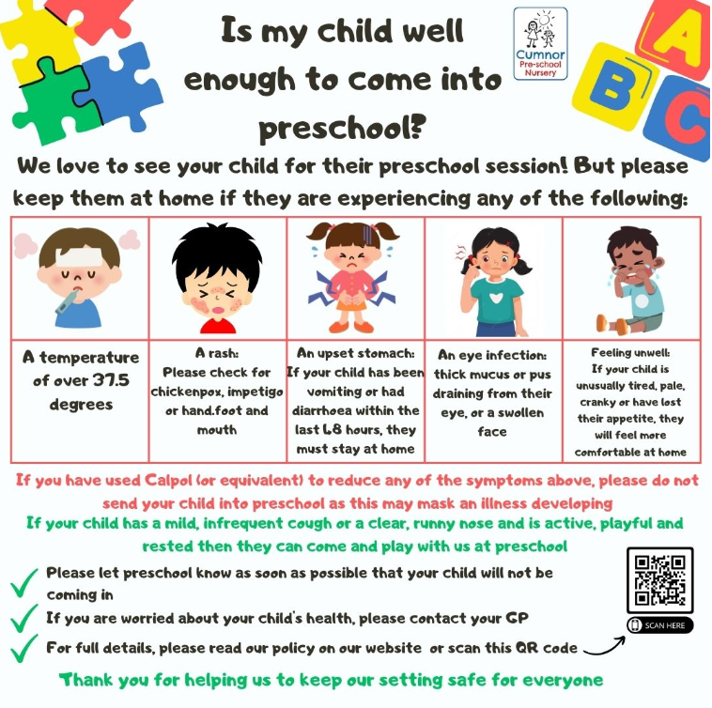

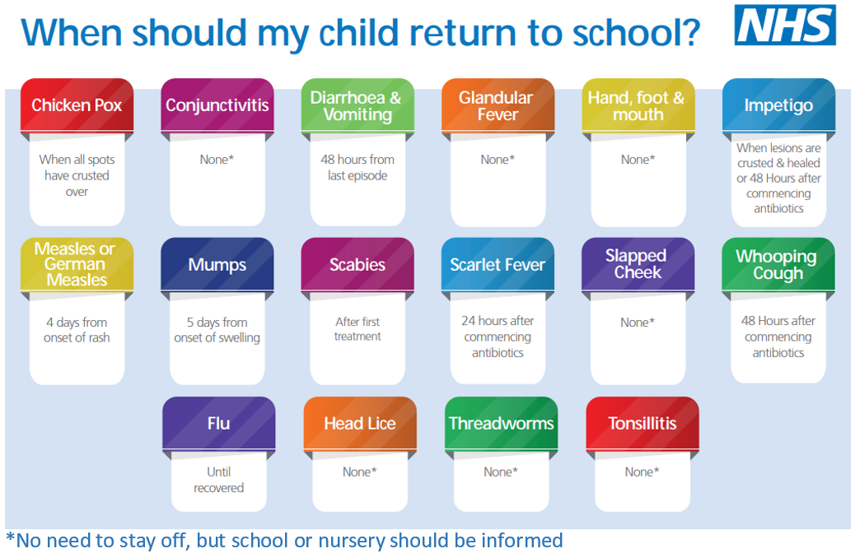
Appendix 2

This policy was adopted by | Cumnor Pre-school Nursery | (name of provider)
On | 21 June 2023 | (date)
Date to be reviewed | Term 1 - 2023 | (date)
Signed on behalf of the provider
Name of signatory
Role of signatory (e.g. chair, director or owner) | Chair

Other useful Early Years Alliance publications

- Good Practice in Early Years Infection Control (2009)
- Medication Administration Record (2013)
- Procedures for Children who are Poorly – EYA
- UKHSA Publications – Should I keep my child off school
- NHS England – When should my child return to school

