Cumnor Pre School Nursery Uniform

At Cumnor Pre School Nursery we like the children to look smart and to feel part of the community to which they belong. We feel that this makes a positive contribution to the Nursery’s ethos and helps to avoid any discrimination.
At our most recent Committee Meeting, it was decided that from September 2021, we would like all of our children to wear where possible the Pre-school t-shirts and/or sweatshirts during their sessions with us. Not only does this give them a sense of belonging to Pre-school but also saves the ‘wear and tear’ on their other clothes. The t-shirts and sweatshirts are comfortable and safe for active learning in the garden; messy play can be enjoyed without worrying about other clothes getting muddy or covered in paint and will hopefully save time in the morning whilst your child decides what they want to wear!
All uniform is available from the Pre-school. Please complete the form below or collect an order form from the Pre-school.
We have a limited number of good quality second-hand t-shirts and sweatshirts which can be purchased through the nursery at £2 per item. Please ask a member of staff.
We do highly recommend our t-shirts and sweatshirts for your children and hope that you will support us in our decision.
If you have any questions or concerns, please do not hesitate to contact us.
……………………………………………………………………………………………………………………………………………………………
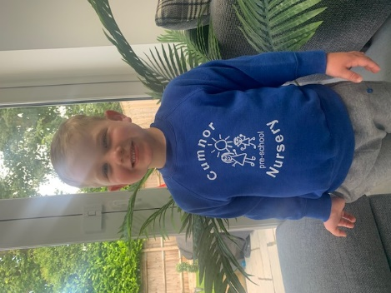
Sweatshirt
Colour: Blue with Cumnor Preschool Logo
Sizes: 1-2 years, 3-4 years or 5-6 years
Cost: £11.00

T-Shirt
Colour: Blue with Cumnor Preschool Logo
Sizes: 1-2 years, 3-4 years or 5-6 years
Cost: £6.00
To order any of the above items, please complete the form and return to the Pre-school with payment or pay online to Cumnor Preschool Nursery, Acc no: 80309303 Sort code: 20-65-18 (please reference “uniform” and your child’s name)

Name of child:…………………………………………………
 | Item | Size | Quantity | Cost
1.
2.
3.
4.
 |  |  | Total: | £

Print Name……………………………………………………………………
Signed:…………………………………………………
Date:…………………………………………………………………….
A member of the Early Years Alliance Registered charity no. 279672

