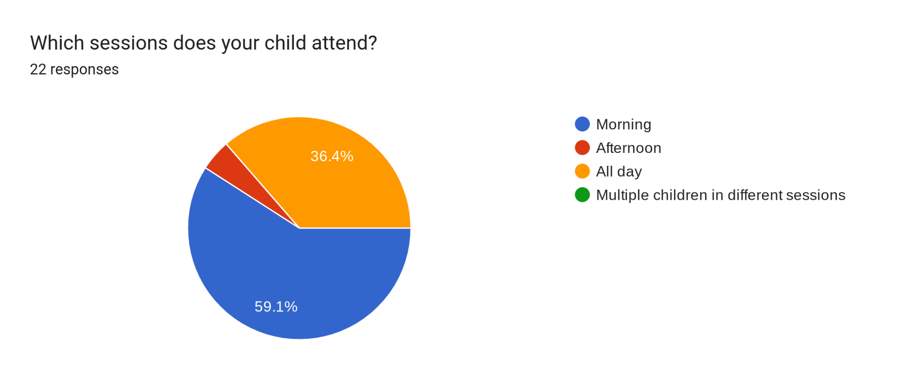

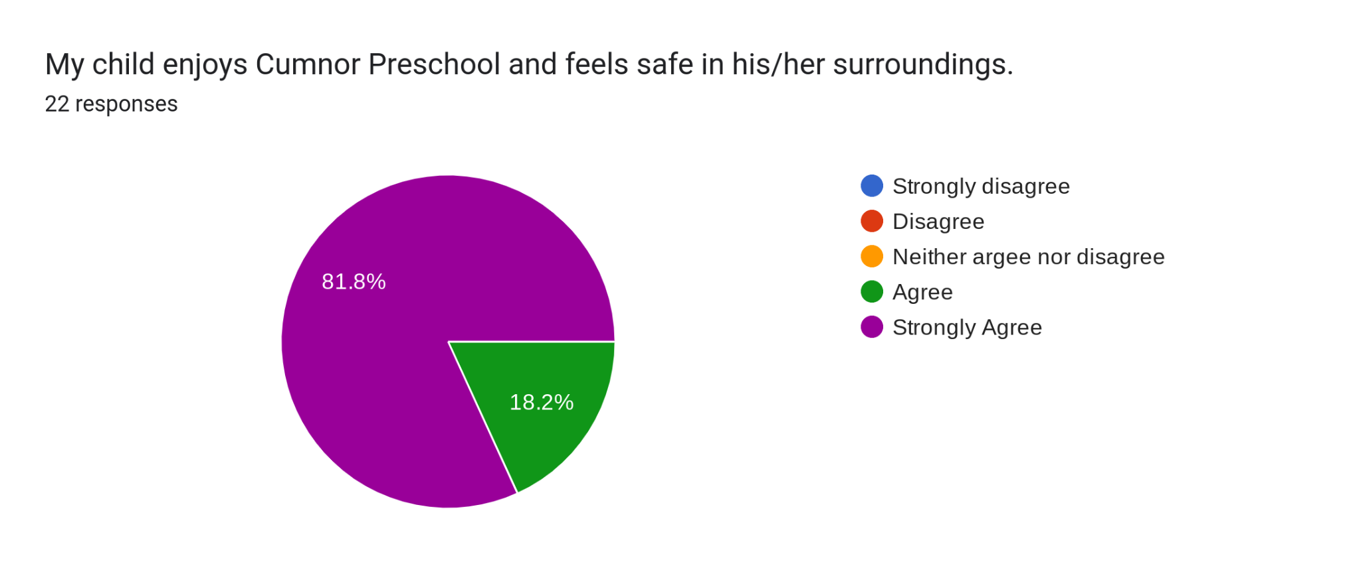

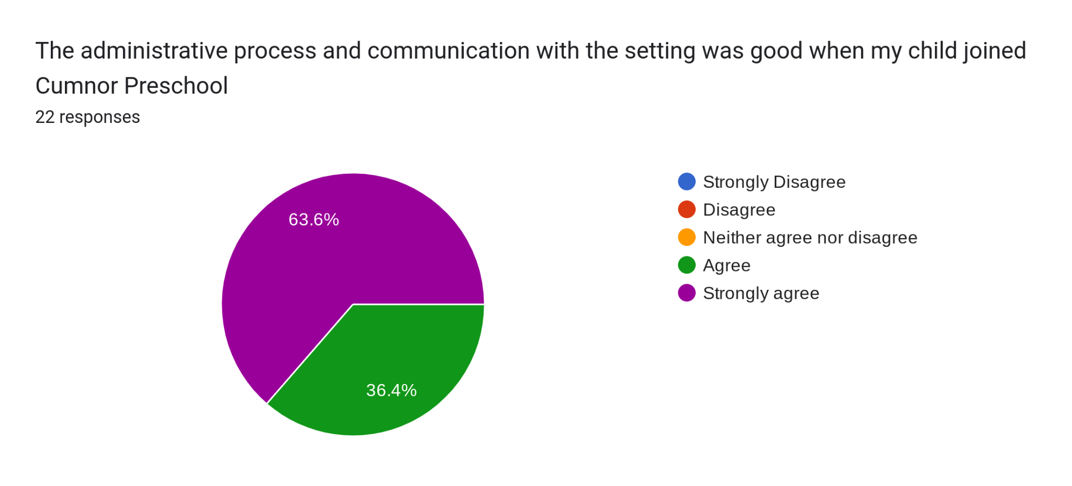
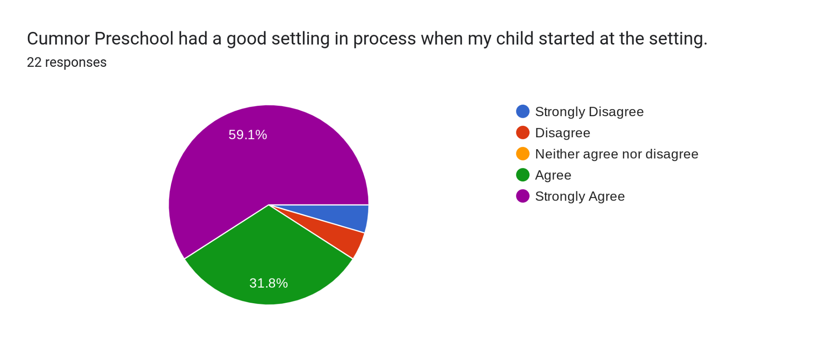
When your child started Pre-school what did you particularly like - is there anything which could have been improved?13 responses
It has been a wonderful experience. I particularly like the Tapestry app.
Just loved how friendly and supportive the staff was
Particularly like the staff and variety of activities.
Our child settled in quickly so we were happy.
Welcoming my child was very good and lovely and we felt safe to leave her there.the support as they supported and still support xxxxxx about her differences. Lovely, helpful staff
Friendly staff, inviting environment to play.
I really appreciated the observations on tapestry-I was anxious about his settling in
Everything is exceptional.
Bigger place

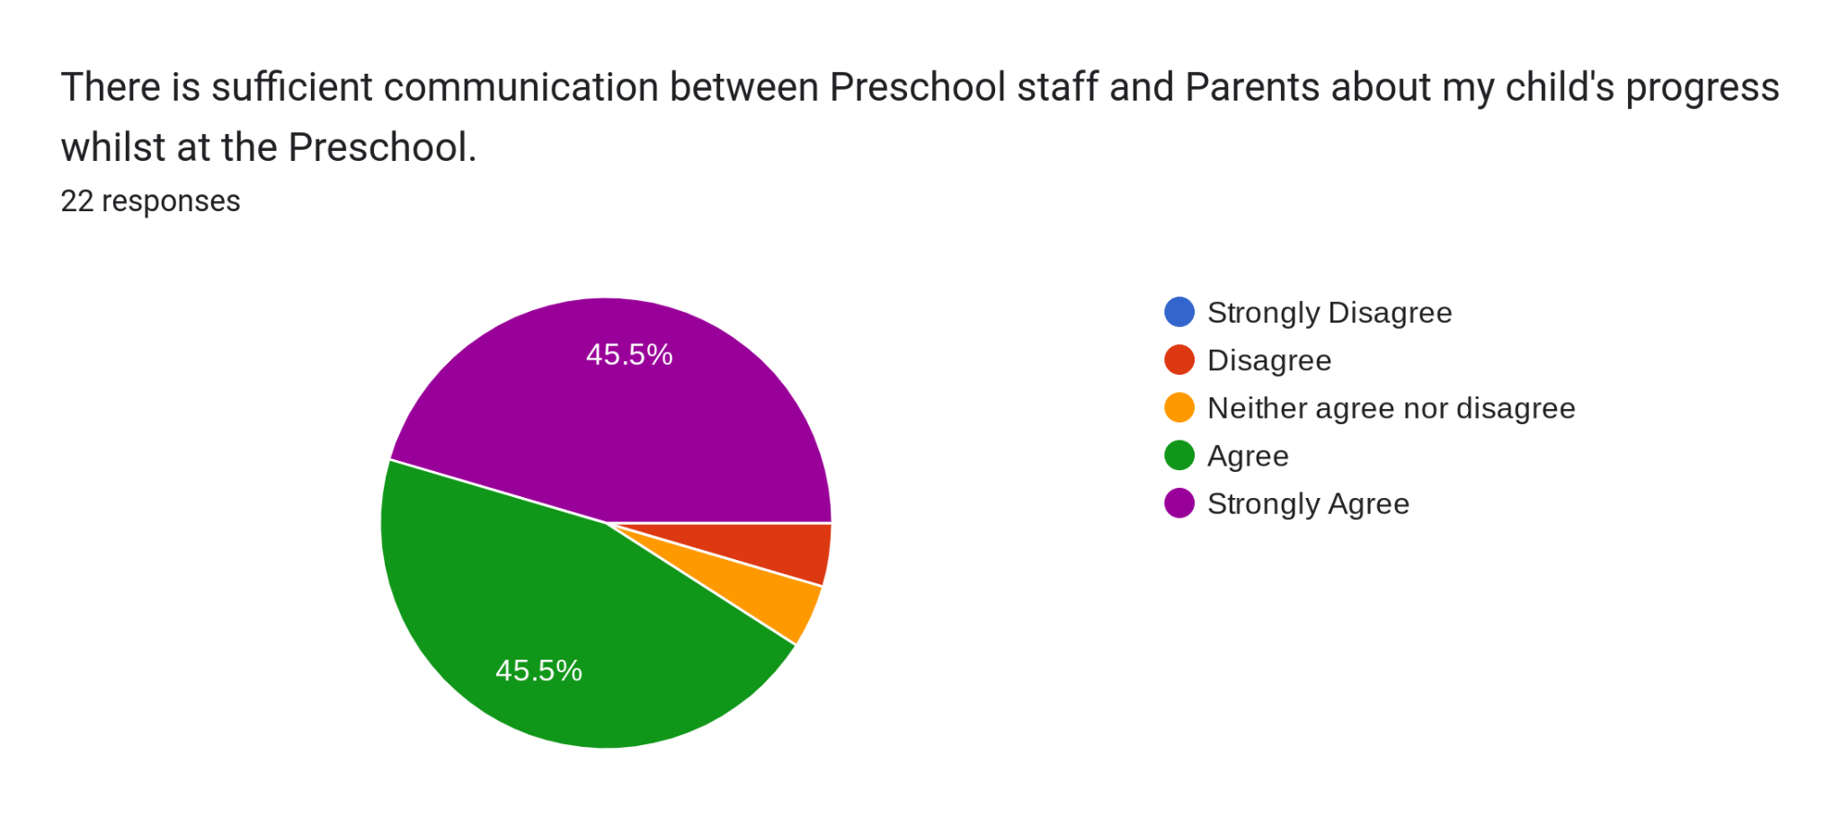

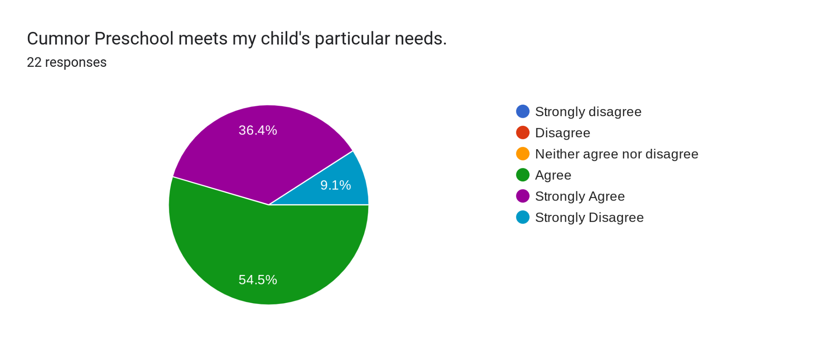

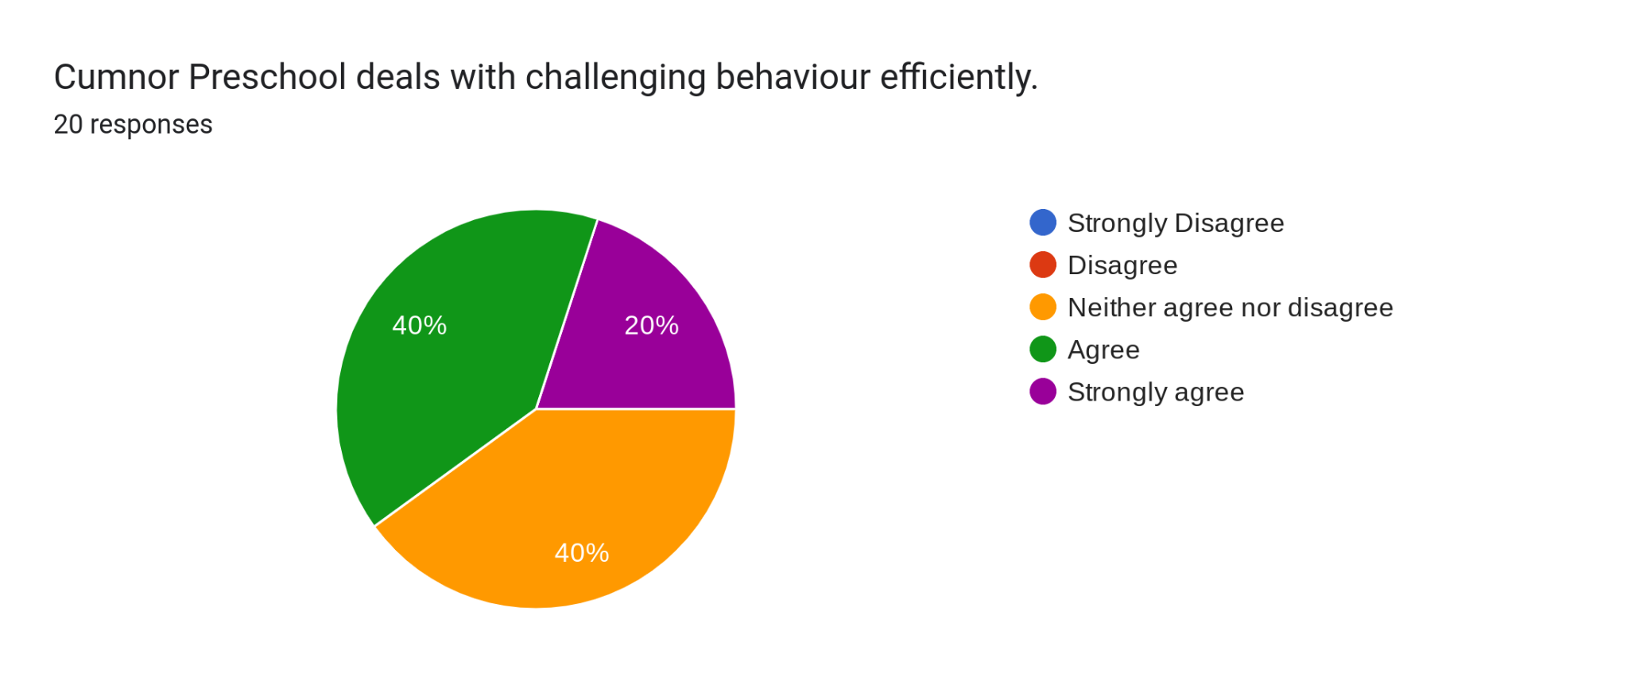

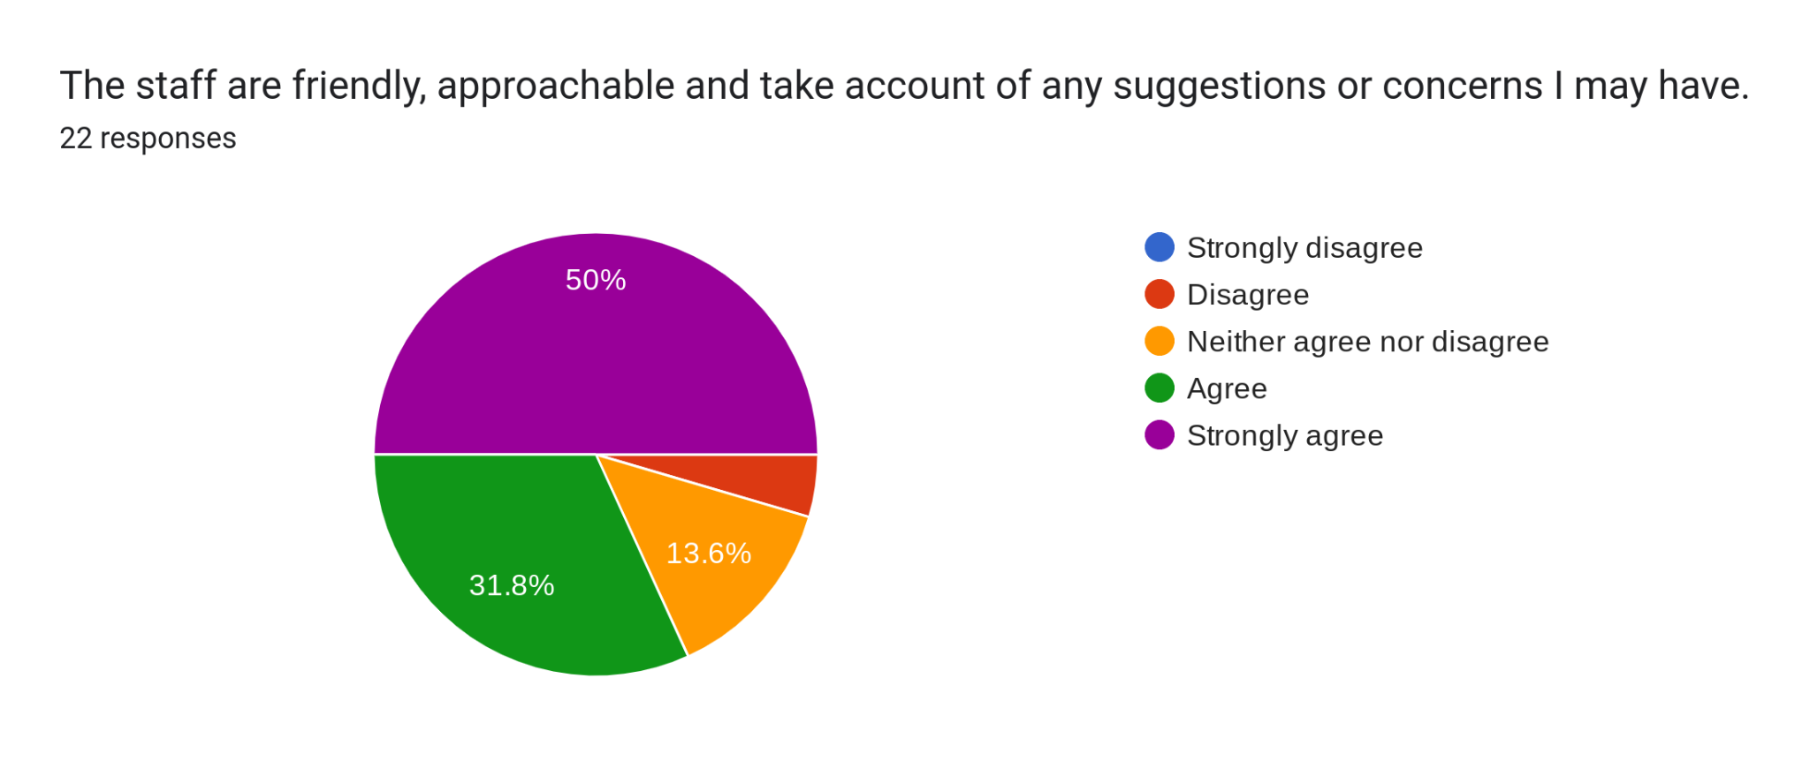

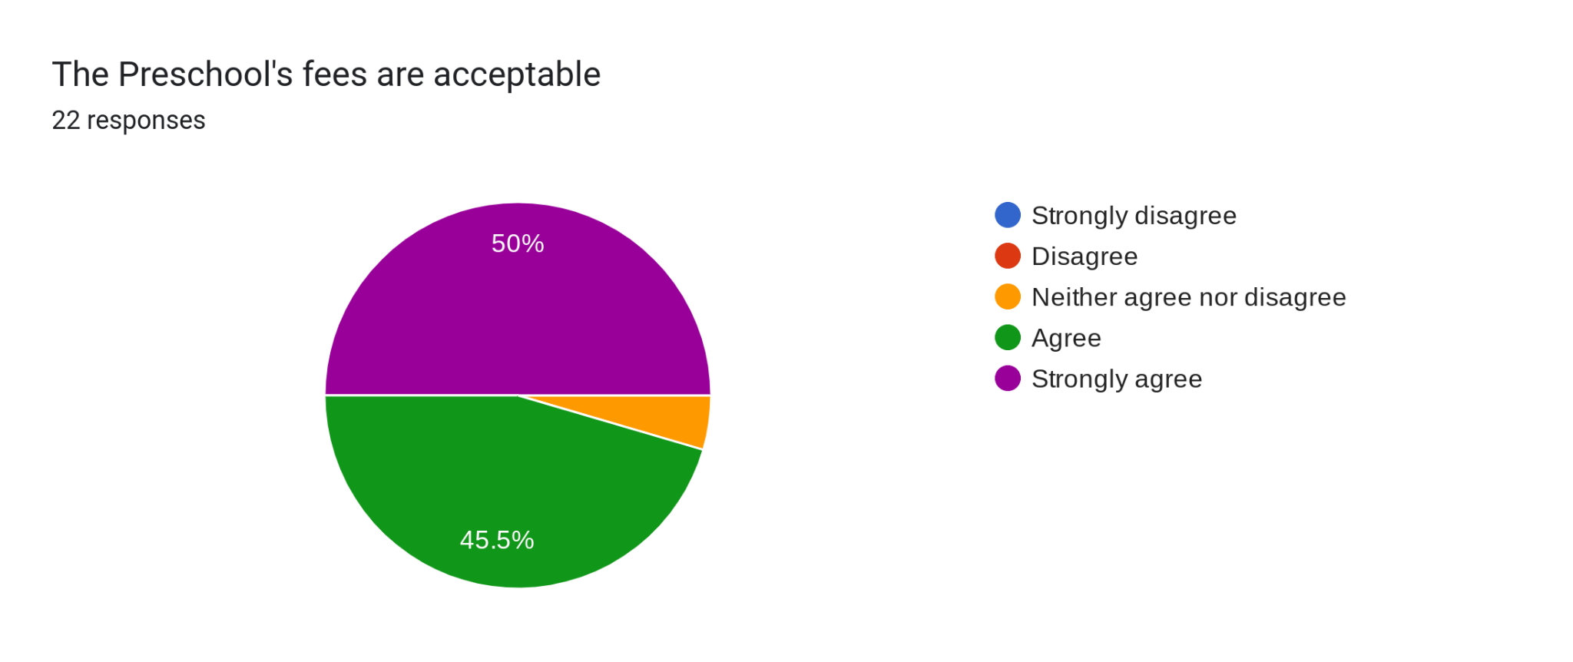

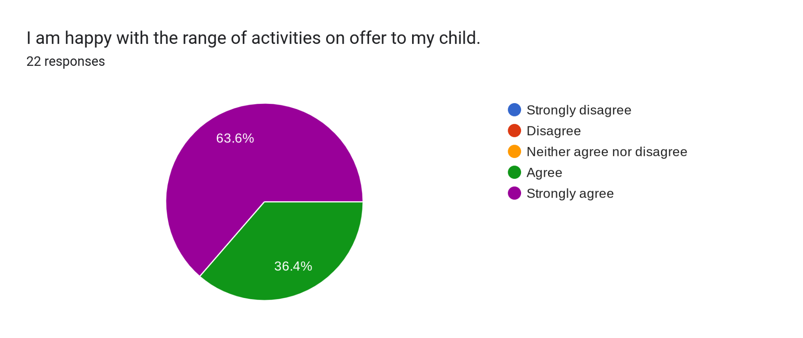

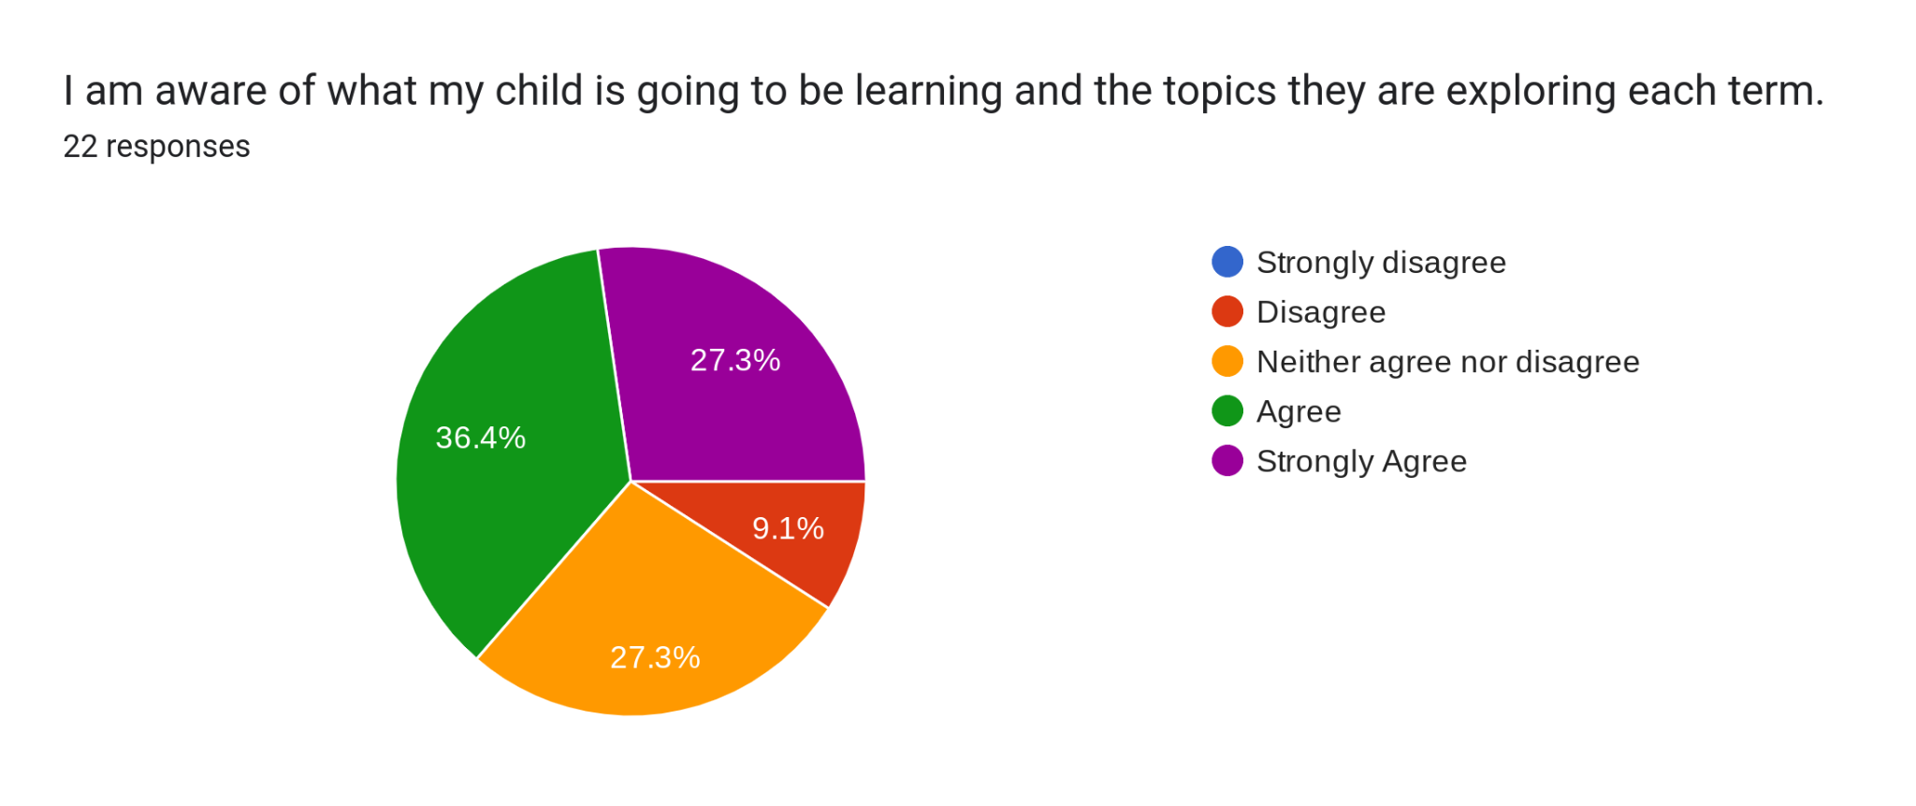

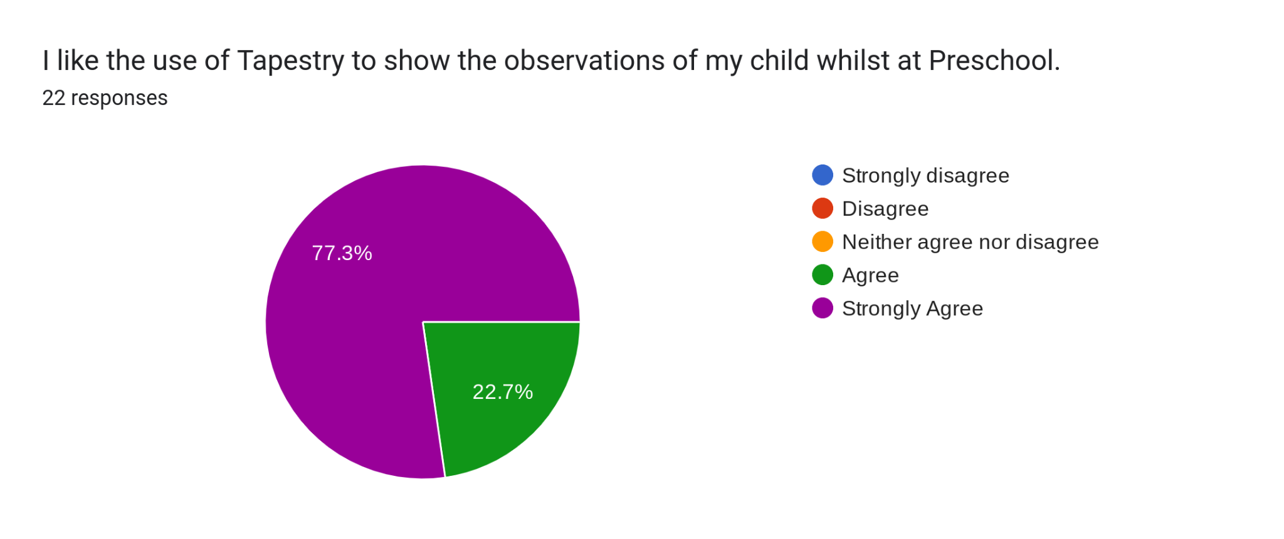

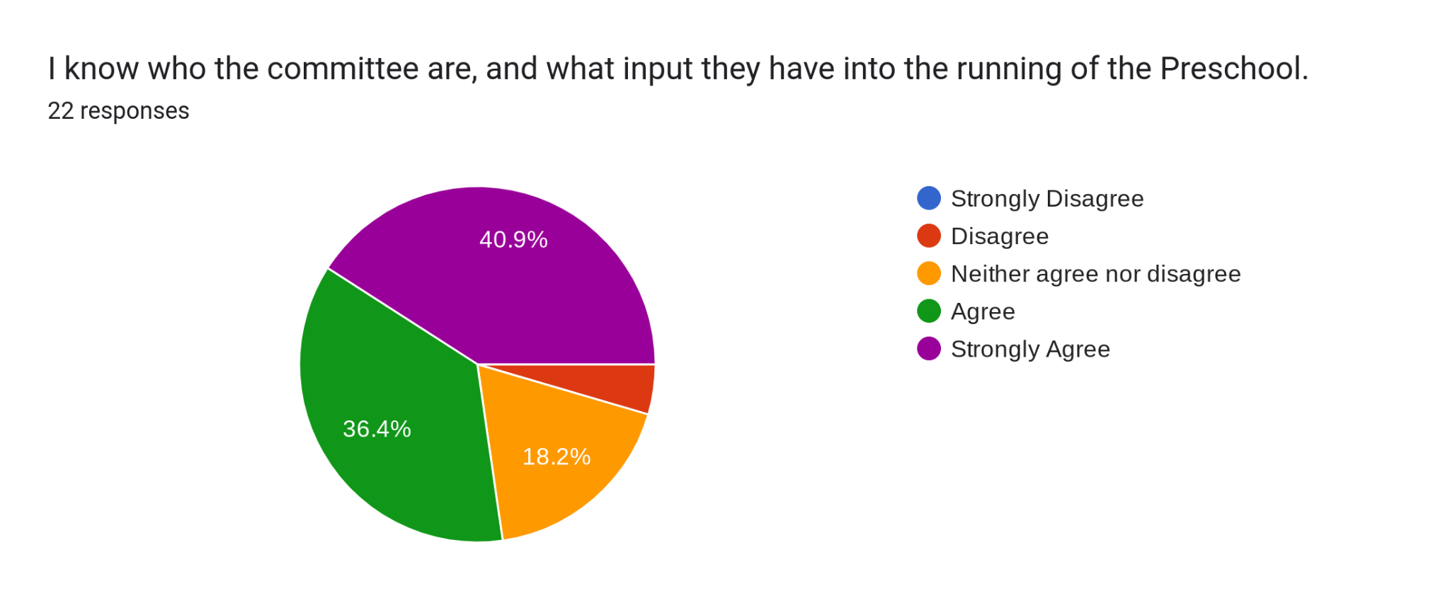

Any comments2 responses
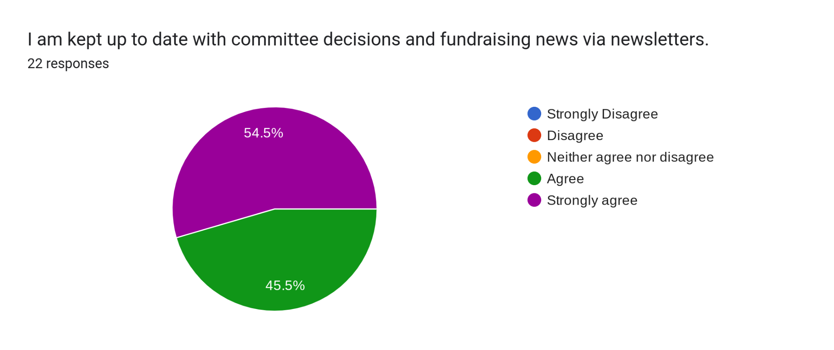

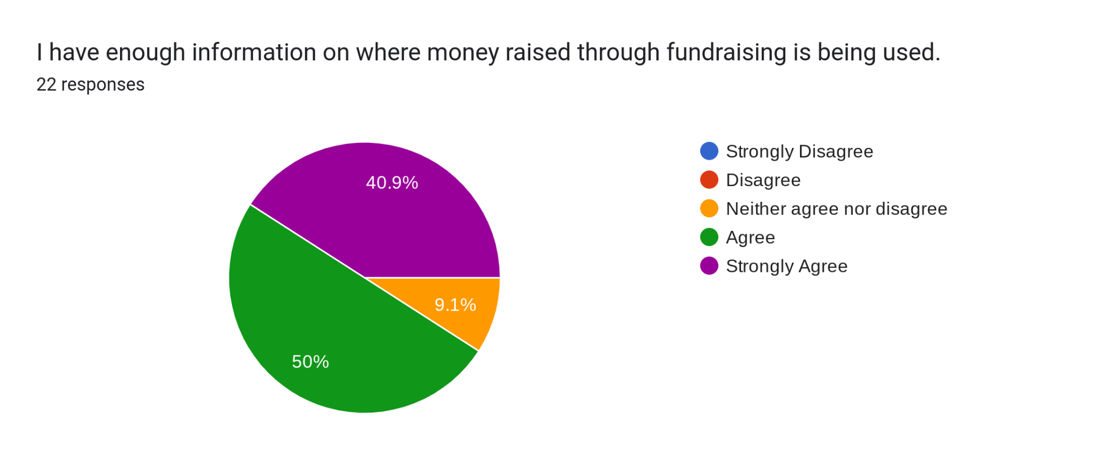

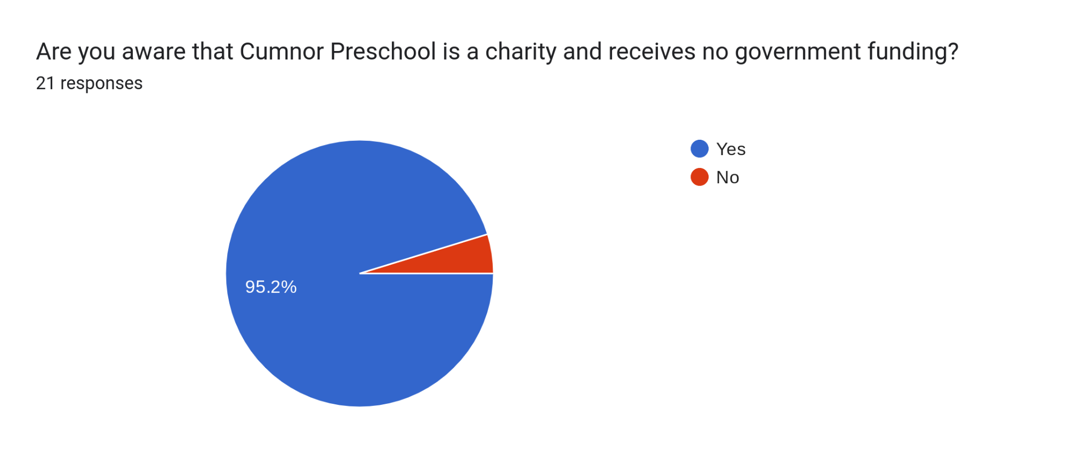

Any further comments you may have for the Preschool staff or the committee?9 responses
We love the preschool setting and would use it more if the opening times were more in line with the school. 9am drop off is difficult. Also, shutting at noon before half term breaks makes it almost unusable with older siblings letting out at 1:10pm. It makes it very difficult for working parents or families with older children at the primary school to utilise the preschool.

I have a child at Cumnor School, and it would be a lot easier if there was not such a disparity between the school start time and the nursery start time. A start time of 8.45 would be ideal.
Our child is very happy here thank you.
Thankyou to you for being such a warm and welcoming environment for our daughter to play, learn and develop.

thank you, we are very happy. I would like to know what he is eating and how much of it, so I plan his remaining meals accordingly

I think the pre-school is wonderful. My only wish is that it would open at 8.50 in line with school drop off time to save standing about and being late for 9am commitments. I know this is a challenge of many and not just myself.

A start time in line with school drop off would make a huge difference to parents being able to more effectively manage their work commitments (the difference between being home at 9 vs 9.20 does make a huge difference to us) , and would, I expect, make the preschool a more viable option for more families. We'd be happy to pay for this.

Would the preschool ever consider taking the younger children for whole day sessions? Or any after 3pm sessions to tie into after school clubs at school, or the after school club, so that families with children at the school can make more efficient use of the time spent journeying to and from the preschool / school premises.

These are just ideas which I'd be very keen to know more about. But we love the preschool, and our little one is very happy. Thank you all!
My child is very happy at Preschool, which makes us as parents very happy! Tapestry is great and allows me to see what my child is doing every day.
So many thanks for everything you do to help xxxx grow and develop skills for life

